Federal University Lokoja

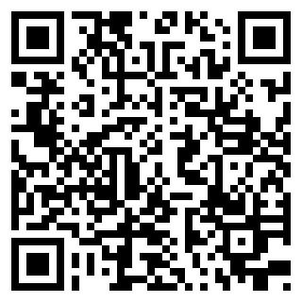

**REGISTERED COURSES**

# (Office of the Registrar)

**EXAM CARD**

# 1ST SEMESTER 2023/2024 ACADEMIC SESSION

**CANDIDATE INFORMATION**

**Matric No.:** EDU20SED279

**Faculty:** EDUCATION

**Course of Study:** MATHEMATICS EDUCATION

**Gender:** Male

**Name:** Emmanuel Temitope JOSHUA **Department:** SCIENCE EDUCATION **Level:** 400

**Payment RRR:** 341062176598

|  |  |  |  |  |
| --- | --- | --- | --- | --- |
| **#** | **Code** | **Title** | **Category** | **Unit** |
| **1ST SEMESTER COURSES** | | | | |
| 1. | EDU411 | Curriculum and Instruction 1 | Core | 2 |
| 2. | EDU413 | Entrepreneurship Skill in Education | Core | 2 |
| 3. | EDU415 | Introduction to Educational Management | Core | 2 |
| 4. | EDU419 | Seminars in Subject Areas in Education | Core | 1 |
| 5. | EDU423 | Information and Communication Technology in Education | Core | 2 |
| 6. | MTH401 | Theory of Diﬀerential Equations | Core | 3 |
| 7. | MTH403 | Advance Real Analysis | Core | 3 |
| 8. | MTH405 | Theory of Finite Groups | Core | 3 |
| 9. | SED411 | Handling DiﬀIcult Science and Mathematics Concepts | Core | 1 |
| 10. | SED417 | Practical Mathematics | Core | 1 |
| 11. | MTH301 | Mathematical Methods II | Core | 3 |
| 12. | EDU213 | Special Method I | Core | 2 |
| 13. | STA211 | Probability Distribution I | Core | 3 |
| **Total Unit (1st Semester):** | | | | 28 |

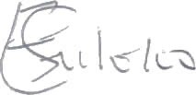

**Head of Department**

**Dr Uloko Emmanuel**

**Thursday 19th June, 2025 10:06 PM**

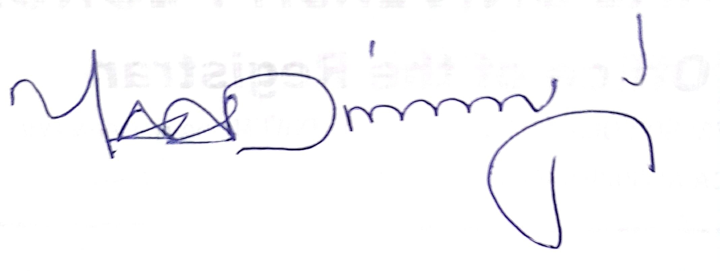

**Academic Secretary**

**Mr Ayuba Adinoyi Yahaya**

**Thursday 19th June, 2025 10:06 PM**

**Examination Instructions**

* Candidates must present themselves at the examination venue 30 minutes to the scheduled time of commencement of the examination
* Each candidate is expected to present his/her identity card and examination slip after having satisfied all the requirements of the University
* Candidates will not be admitted into the examination hall after the examination has been in progress for 30 minutes
* Candidates would not also be allowed to leave the examination hall during the first 30 minutes and the last 15 minutes of an examination
* All brief cases, handbags, mobile phones, electronic programmable calculator, laptop, earpiece, wallet, and any other incriminating/extraneous materials are prohibited in and around the exam hall. Default of the above will attract siezure, confiscation and sanction using the relevant law as contained in the student handbook
* It is compulsory for candidates to sign the examination attendance register when the examiners/invigilators present it to them during the examination
* Candidates must ensure that their answer scripts are handed over to the examiner/invigilator before leaving the examination hall
* Smoking, chewing of gums and the consumption of food and drinks are not permitted during the examination

For support and enquiry, [**portalsupport@fulokoja.edu.ng**](mailto:portalsupport@fulokoja.edu.ng)

Copyright © 2012 - 2025. Federal University Lokoja | All Rights Reserved | Powered by FULokoja ICT Team